1. Frontend (Node.js with Express):
- Create a frontend using Express and Node.js.
- Include a form similar to the one from the Flask Assignment 2.
- Configure the form to send a request to the Flask backend.
- Backend (Flask):
- Use the Flask backend to handle the form submission and process the data.
- Folder Structure:
- Organize the project with separate folders for the frontend and backend.
- Docker Configuration:
- Create a Dockerfile for both the frontend and backend.
- Write a .yaml file (Docker Compose) to connect both services in the same network.
- Upload both images to docker hub and push your whole code to github and add the node_modules and other non-required files(.vscode) in .gitignore

Ans:
Github url:
https://github.com/gbpraveen5/tutedude/tree/main/DevOps/05-Docker%20Frontend%20Assignment

Project Folder Structure:
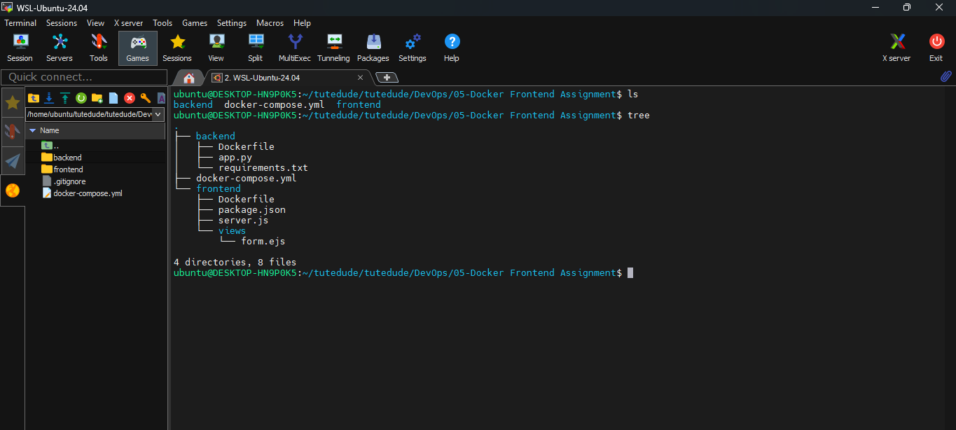
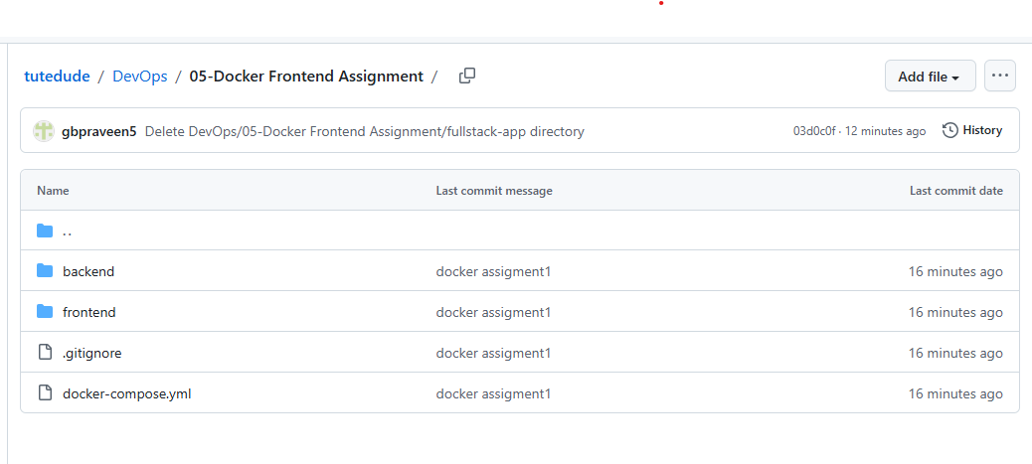
docker-compose up –build:
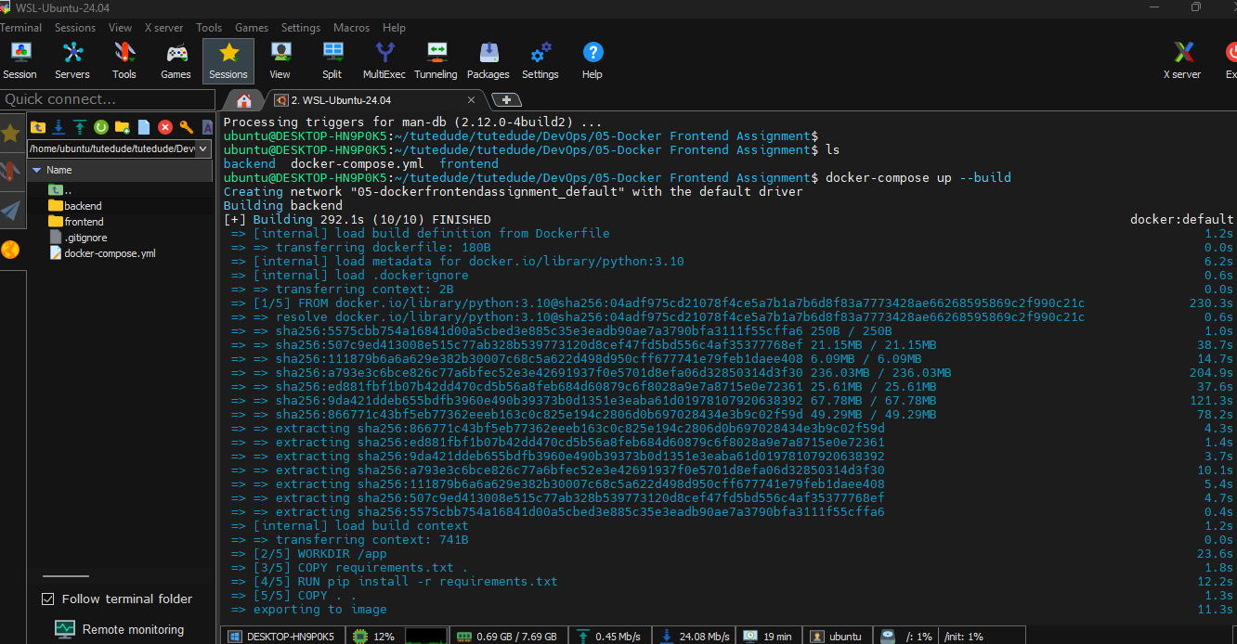

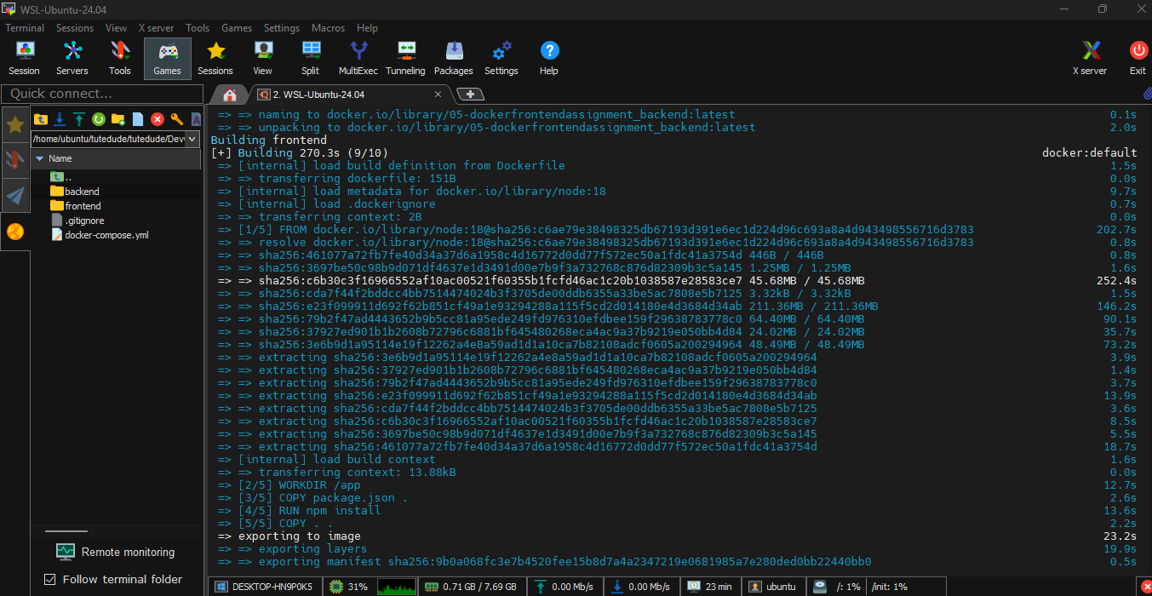

http://localhost:3000
